# FIELD PROJECT REPORT ON

# *FUNCTIONING OF A LOCAL DIAGNOSTIC*

# AT

# *RAPID DIAGNOSTICS AND CLINICS*

#### A Report submitted

#### by

## ARGULA VARSHINI

## 20951A05N9

*IARE-New-Logo_Black.png*

**COMPUTER SCIENCE ENGINEERING**

**INSTITUTE OF AERONAUTICAL ENGINEERING**

### (Autonomous)

### Dundigal, Hyderabad – 500 043, Telangana

## April, 2022

## Picsart_22-07-01_23-27-07-570.jpg

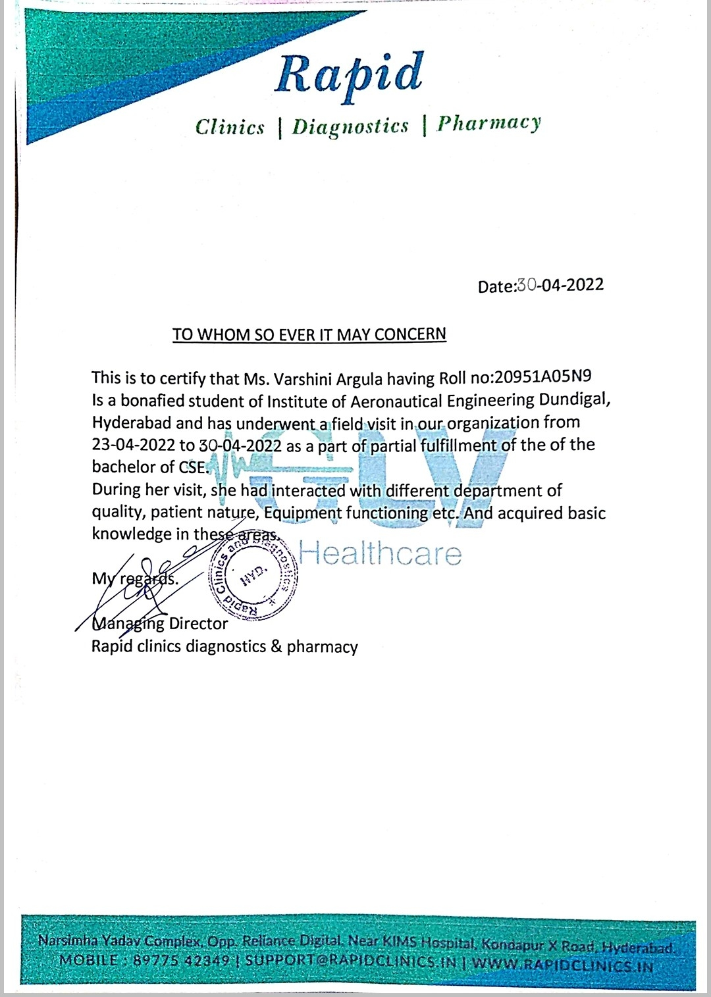

 INSTITUTE OF AERONAUTICAL ENGINEERING

# (Autonomous)

Dundigal, Hyderabad - 500 043

# STUDENT DETAILS

|  |  |
| --- | --- |
| Name of the Student | ARGULA VARSHINI |
| Roll Number | 20951A05N9 |
| Department | COMPUTER SCIENCE ENGINEERING |
| Year / Semester | II year / IV semester |
| Mobile Number | 6309691112 |
| Email ID | varshu.argula@gmail.com |

1. **MENTOR DETAILS**

|  |  |
| --- | --- |
| Name of the Mentor | PALLE GURUVAIAH |
| Organization | RAPID CLINIC AND DIAGNOSTICS |
| Designation | MANAGING DIRECTOR |
| Email ID | [gmpalle@gmail.com](mailto:gmpalle@gmail.com) |
| Mobile Number | 9849914784 |

# TITLE OF THE FIELD PROJECT

# FIELD PROJECT WORK AT RAPID CLINICS DIAGNOSTICS AND PHARMACY

1. **PURPOSE**

The main purpose to conduct this project workisTo understand functioning of a local private diagnostic, To gain knowledge on a diagnostic centre’s internal affairs, To develop interpersonal skills by interacting with random patients.

# OBJECTIVES

The main objectives in this project work are Interaction with diagnostic centre’s management head to gather info regarding the functioning of the diagnostic centre, Discussion about equipment functionalities present at the clinic with a working nurse , Gaining knowledge on the internal affairs of the diagnostic centre from working staff, Communicating with random patients regarding their issues and their experience with the diagnostic, Helping patients to receive right treatment according to their conditions.

**6. DESCRIPTION OF THE FIELD VISIT**

**INTRODUCTION:**

The recent years have been tough for all the people due to the pandemic that caused many

problems to the entire living. Hospitals, clinics, diagnostics and many medical departments have saved many lives. To understand the post covid situation, I have visited the diagnostics named Rapid Clinics and Diagnostics to gain knowledge on different aspects. In this field visit, I mainly focused on understanding the functioning of a diagnostic, gaining knowledge on a diagnostic's internal affairs and developing interpersonal skills by interacting with random patients.

**BACKGROUND:**

The field I have visited is Rapid Clinic and Diagnostics, located at H.No. 2-41/14/1 Narsimha Yadav Complex, opp. Reliance Digitals, Kondapur, Telangana 500084. During this project work, I have gained knowledge about the working and functions of a few equipment at the diagnostics, health issues of random patients visited and how the organization has helped the patients by treating and diagnosing their health issues.

**NATURE OF WORK:**

The nature of work is based on complete awareness of a local private diagnostic center.  Aim of this field project is to interact with management and patients visiting the selected diagnostic center and to understand all the internal affairs and patient experience. Rapid clinic and diagnostic center is the selected field to execute my project work. It is located at H.No. 2-41/14/1 Narsimha Yadav Complex, opp. Reliance Digitals, Kondapur, Telangana 500084.

        By the end of the project work completion, I was able to understand the functioning of a local private diagnostic center, gain knowledge on a diagnostic center's internal affairs and developed interpersonal skills by interacting with random patients and management. This Rapid Clinic and Diagnostics functions as a diagnostic center combined with a clinic works daily with an outpatient number of 50-65 on average. This is a 7 day working project performed from 23/03/2022 to 30/03/2022. In these 7 days, I've met multiple personalities and gathered sufficient information to keenly understand the management and daily functioning of a local private diagnostic. This report is prepared after the field work and categorized into multiple case studies consisting of all the data gathered from each person I've met at the field.

CASE STUDY-1:

The first case study is written about the interaction with the owner of the diagnostic center visited.Mr. Guruvaiah Palle is the 46-year-old owner of this diagnostic center. He resides near the diagnostic center 2km away at kondapur. He takes care of all the external affairs such as import of equipment and stock, financial affairs and management. I've talked to him about all these matters and came to know that he orders stock from a local supply agency. Staff works in 2 shifts per day. At the clinic, a nurse will be present all day and a doctor attends at 2 shifts i.e. morning and evening. Diagnostic and clinic timings are 9 a.m. to 11 p.m

Doctor shifts are 10 a.m. - 2 p.m. and  6 p.m. to 9 p.m. On average, outpatient numbers are 50-65 per day. This diagnostic facilitates 80 different kinds of medical tests and multiple emergency support at clinics. This is the basic information I've collected from the diagnostic owner.

CASE STUDY-2:

This case study is about the discussion on equipment present at diagnosis with a working nurse. Ms. Maidhili is a working nurse at both diagnostic and clinic. She stays at the hostel nearby. She has completed her medical degree and is practicing nursing at this center. She explained to us about the blood pressure examiner used to monitor bp level, yuwell suction apparatus works in removing any impurities or hazardous substances from veins , Oxygen concentrators and all other sample collections equipment. She showed us collecting blood samples from a patient present at the clinic at that moment. She explained a lot about the day to day cases they deal with and all the basic medical precautions to be taken by her in any case.

CASE STUDY-3:-

This case study is about the internal affairs of diagnostic center and clinic with working staff at reception. Ms.K.Lalitha works as a receptionist at the diagnostic center and she also works in financial affairs and part of management. In my enquiry, I came to know that medical stock at the place is received every alternate by placing order at the agency.

On average, 20-30 tests and scannings are done every day by the nursing staff. She takes care of all the equipment and stock work at the diagnostic and clinic. She attends a huge number of calls received every day and works on appointments, working at first shift. She mentioned that she gets paid 15k per month for all the duties.

CASE STUDY-4:

This case study is about an interaction with a patient I've come across at the clinic.Mr. Dheeraj kumar is the patient of age 32 years old patient who was hospitalized. He resides at Kothaguda. He was given an insulin shot because of his abnormal sugar levels and was injected with a bottle of saline. His symptoms when he was hospitalized were irregular heartbeat, sweating, visual disturbances and loss of consciousness. He first visited the diagnostics to take a few tests and then approached the clinic for the treatment. While he was getting his treatment, I suggested him to take a few more additional tests for his safety.

CASE STUDY-5:-

This case study is about another patient interaction at the clinic. Mr. Bala Kumaran is one of the patients approaching this clinic. He is 41 years old . He resides at Madhapur. He was diagnosed with viral fever and has spoke to the doctor. He said that the doctor advised him to take preferred medication as a course and he was injected with 2 types of medicines. At first ,When I spoke to him, he was not ready for saline injection but I recommended that he get injected for glucose growth in his body. I have helped him to get convinced to take saline for glucose growth in blood.He was then injected 3 bottles of saline for maintaining glucose levels and hemoglobin growth medicine was mixed in it. He mentioned that he and his whole family has been visiting this clinic for medical support for a long time.

**7.PHOTOS OF FIELD VISIT WITH DESCRIPTION**

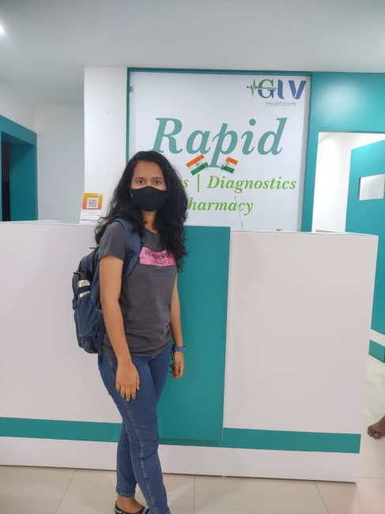

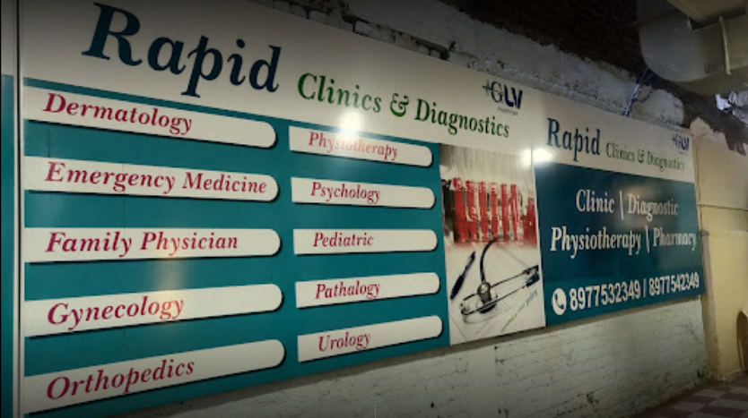

Img.1,2. Photos of field of project conduction

**8.PROJECT DEPLOYMENT PHOTOS WITH DESCRIPTION**

**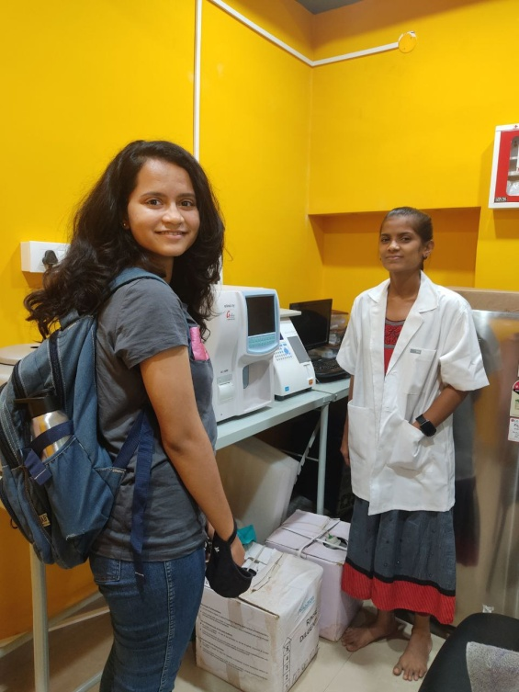**

Imp.1.Discussion with nurse about diagnostic and clinic

equipment working as mentioned in case study 2.

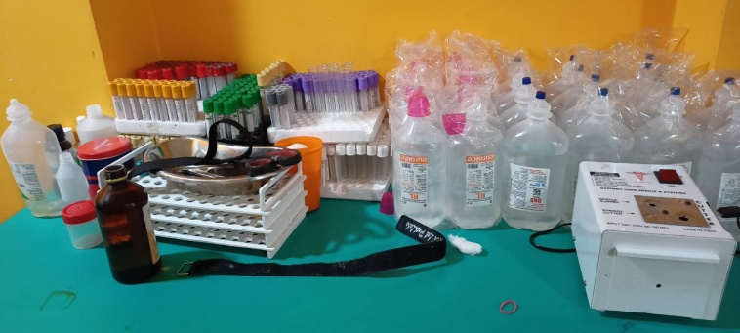

Img.2.Stock present at the clinic I was taught about.

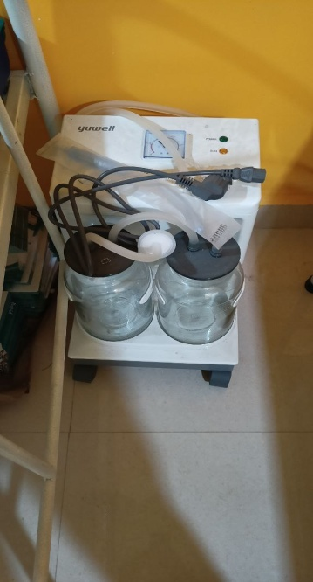

Img.3. Equipment I was taught about by nursing staff

(yuwell suction apparatus)

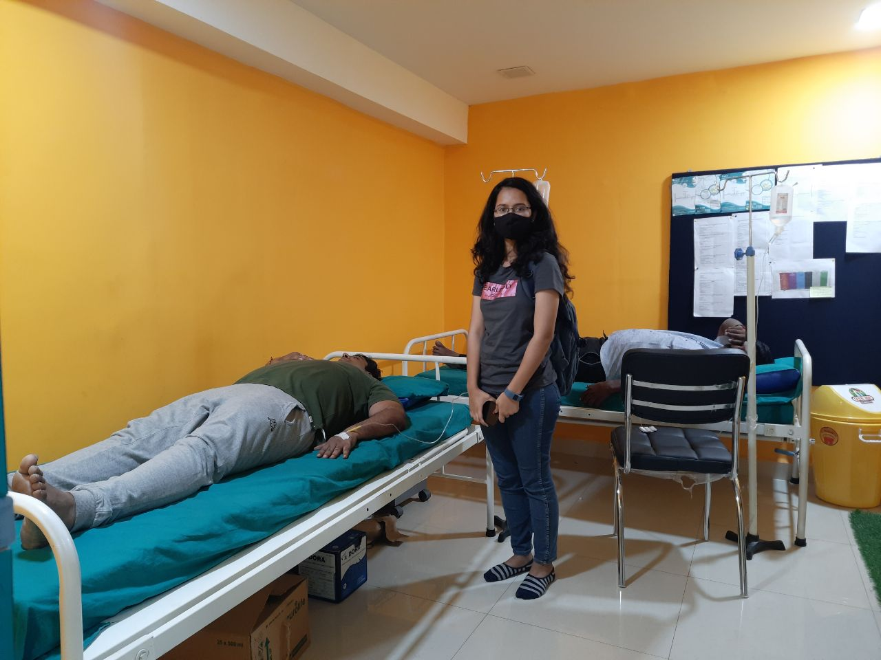

Img.4.Two patients I’ve interacted with.(diabetic on my behind and the one with fever on my right)

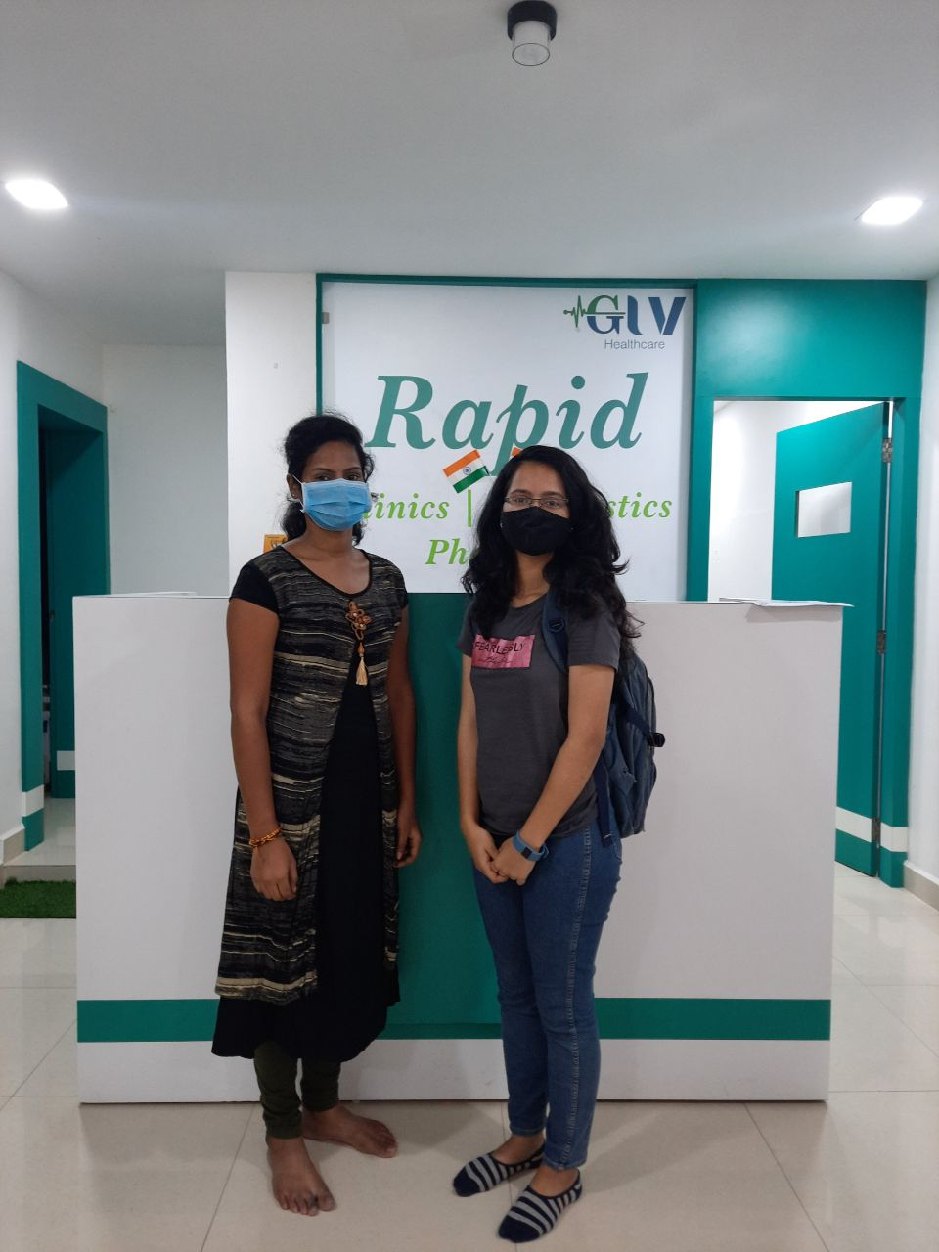

Img.5.Working staff woman whom I’ve enquired about diagnostic’s internal affairs as mentioned case study4.

